Wireshark UDP Lab Report

**BSDSF22A028 [Muhammad Shoaib Ahmad]**

# 1. Screenshot: Starting Wireshark and capturing packets.

# 

# 2. Screenshot: Running nslookup command in terminal/command prompt.

# 

# 3. Screenshot: Stopping capture and filtering UDP packets in Wireshark.

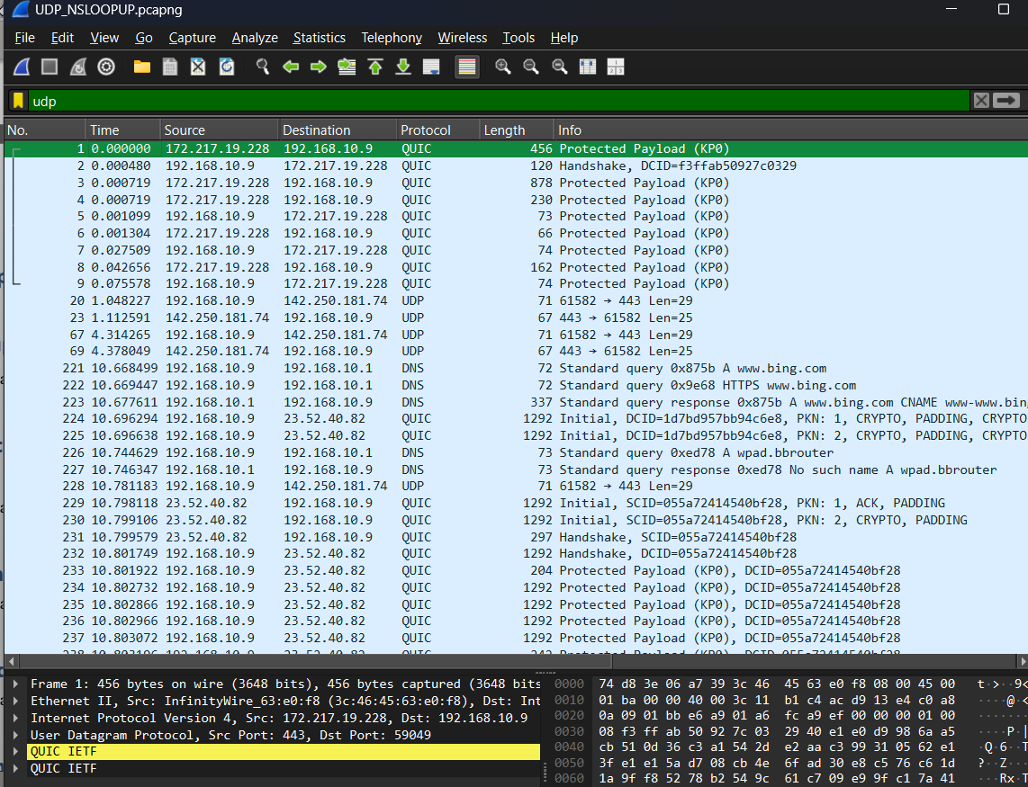

# 4. Screenshot: First UDP packet details (with header fields expanded).

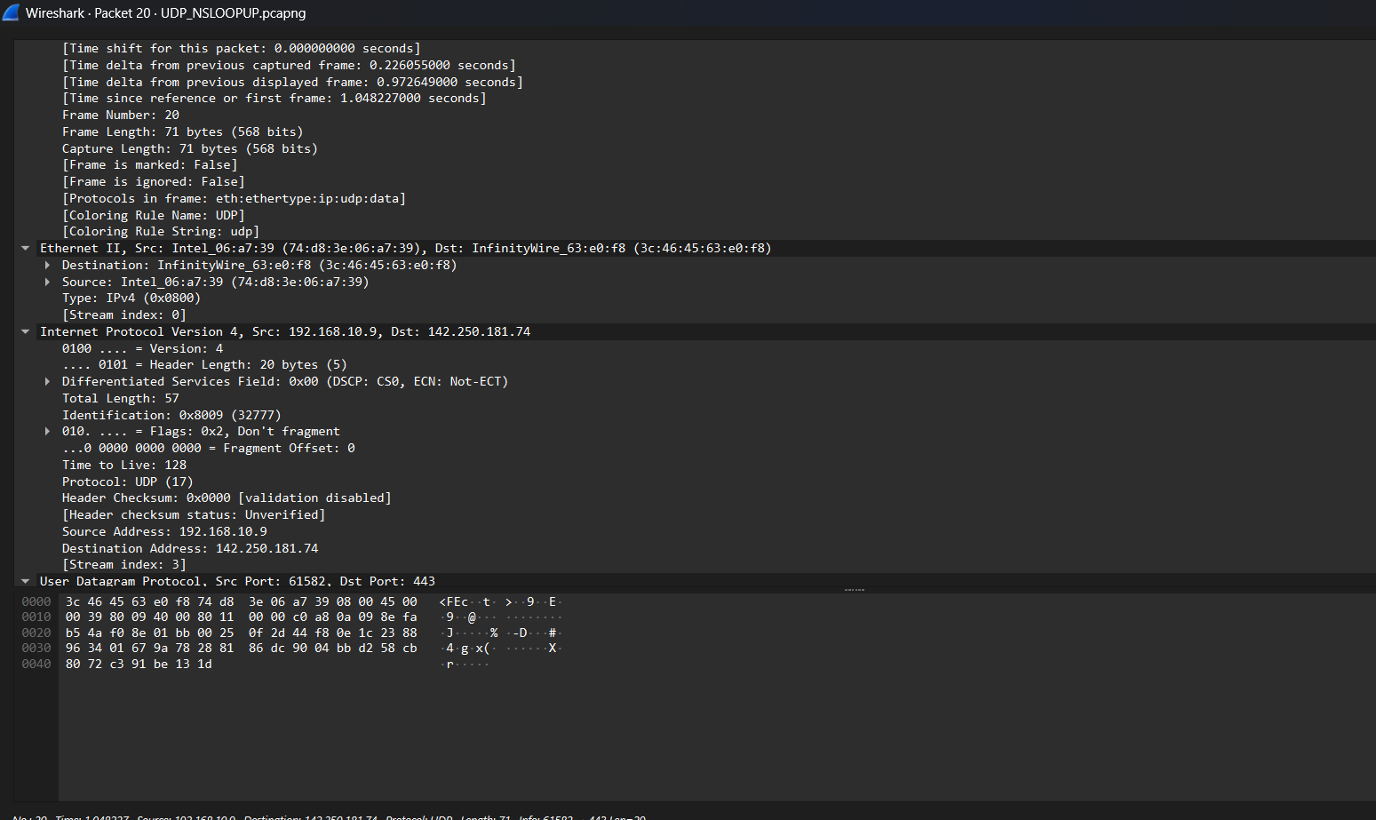

# 5. Answer Q1: Packet number, application-layer protocol, header fields, and their names.

# Packet Number: 2 Application-layer Protocol: DNS Number of UDP Header Fields: 4 Names of the Fields: - Source Port - Destination Port - Length - Checksum

# 6. Answer Q2: Length (in bytes) of each UDP header field.

# Each UDP header field is 2 bytes (16 bits): - Source Port: 2 bytes - Destination Port: 2 bytes - Length: 2 bytes - Checksum: 2 bytes

# 7. Answer Q3: What does the Length field represent?

# The Length field indicates the total length of the UDP header and the UDP data (payload). For example, if the field shows 32, it means 8 bytes of header + 24 bytes of data.

# 8. Answer Q4: Maximum number of bytes in a UDP payload.

# Maximum number of bytes in a UDP payload is 65,507 bytes. This is because the maximum value for the Length field is 65,535 and the header is 8 bytes. So, 65,535 - 8 = 65,507 bytes.

# 9. Answer Q5: Largest possible source port number.

# The largest possible source port number is 65,535. Port numbers are 16-bit unsigned integers.

# 10. Answer Q6: Protocol number for UDP (from IP header).

# The protocol number for UDP in the IP header is 17 (in decimal). This is found in the 'Protocol' field of the IP datagram that encapsulates the UDP segment.

# 11. Screenshot: First and second UDP packets (request and response).

# 

# 12. Answer Q7: Packet numbers of request/response, and relationship between ports.

# Packet Number 1 (Request): [Example: 7] Packet Number 2 (Response): [Example: 8] Relationship between ports: - The source port in the request becomes the destination port in the response. - The destination port in the request becomes the source port in the response.